**Sheet 2**

**Question 1**

Histogram equalize the following 8x8 image where the pixels take on values {0,1,..,7}. Clearly state any assumptions you make.

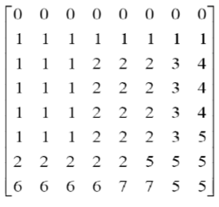

**Question 2**

A 4×4 image is given by

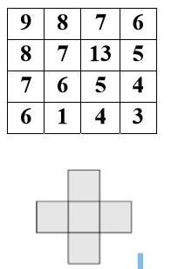

Where the filters mask is given by



a) Filter the image using a Median filter (after replicate-padding).

b) Filter the image using a Min filter (after replicate-padding).

c) Filter the image using a Max filter (after replicate-padding).

d) Filter the image using a Mean filter (after replicate-padding).

e) Compare between mean, median, and Conservative smoothing filters in terms of Noise Suppression and Detail Preservation

**Question 3**

A 4×4, 4bits/pixel image is given by

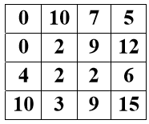

a) Find and sketch the binary form of the image (thresholding).

b) Find and sketch the image complement/negative (inversion).

c) Find and sketch the image identity.

d) Apply average filter with a kernel size 3x3.

**Question 5**

A 4×3 image is given by

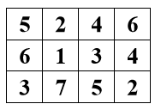

Use Sobel operator to find its edges, estimate the gradient magnitude, and use T = 14 as the threshold for edge detection.